VISIL TECh
Robotics & Automations

HOME AUTOMATION
At Visil Tech, we take pride in being at the forefront of automation technology.

Our commitment to excellence, cutting-edge innovation, and seamless integration of smart solutions make us the undisputed leaders in delivering the ultimate automation experience.

Experience the pinnacle of smart living with us, where every aspect of your home is intelligently connected and effortlessly controlled, setting new standards for comfort, convenience, and security.

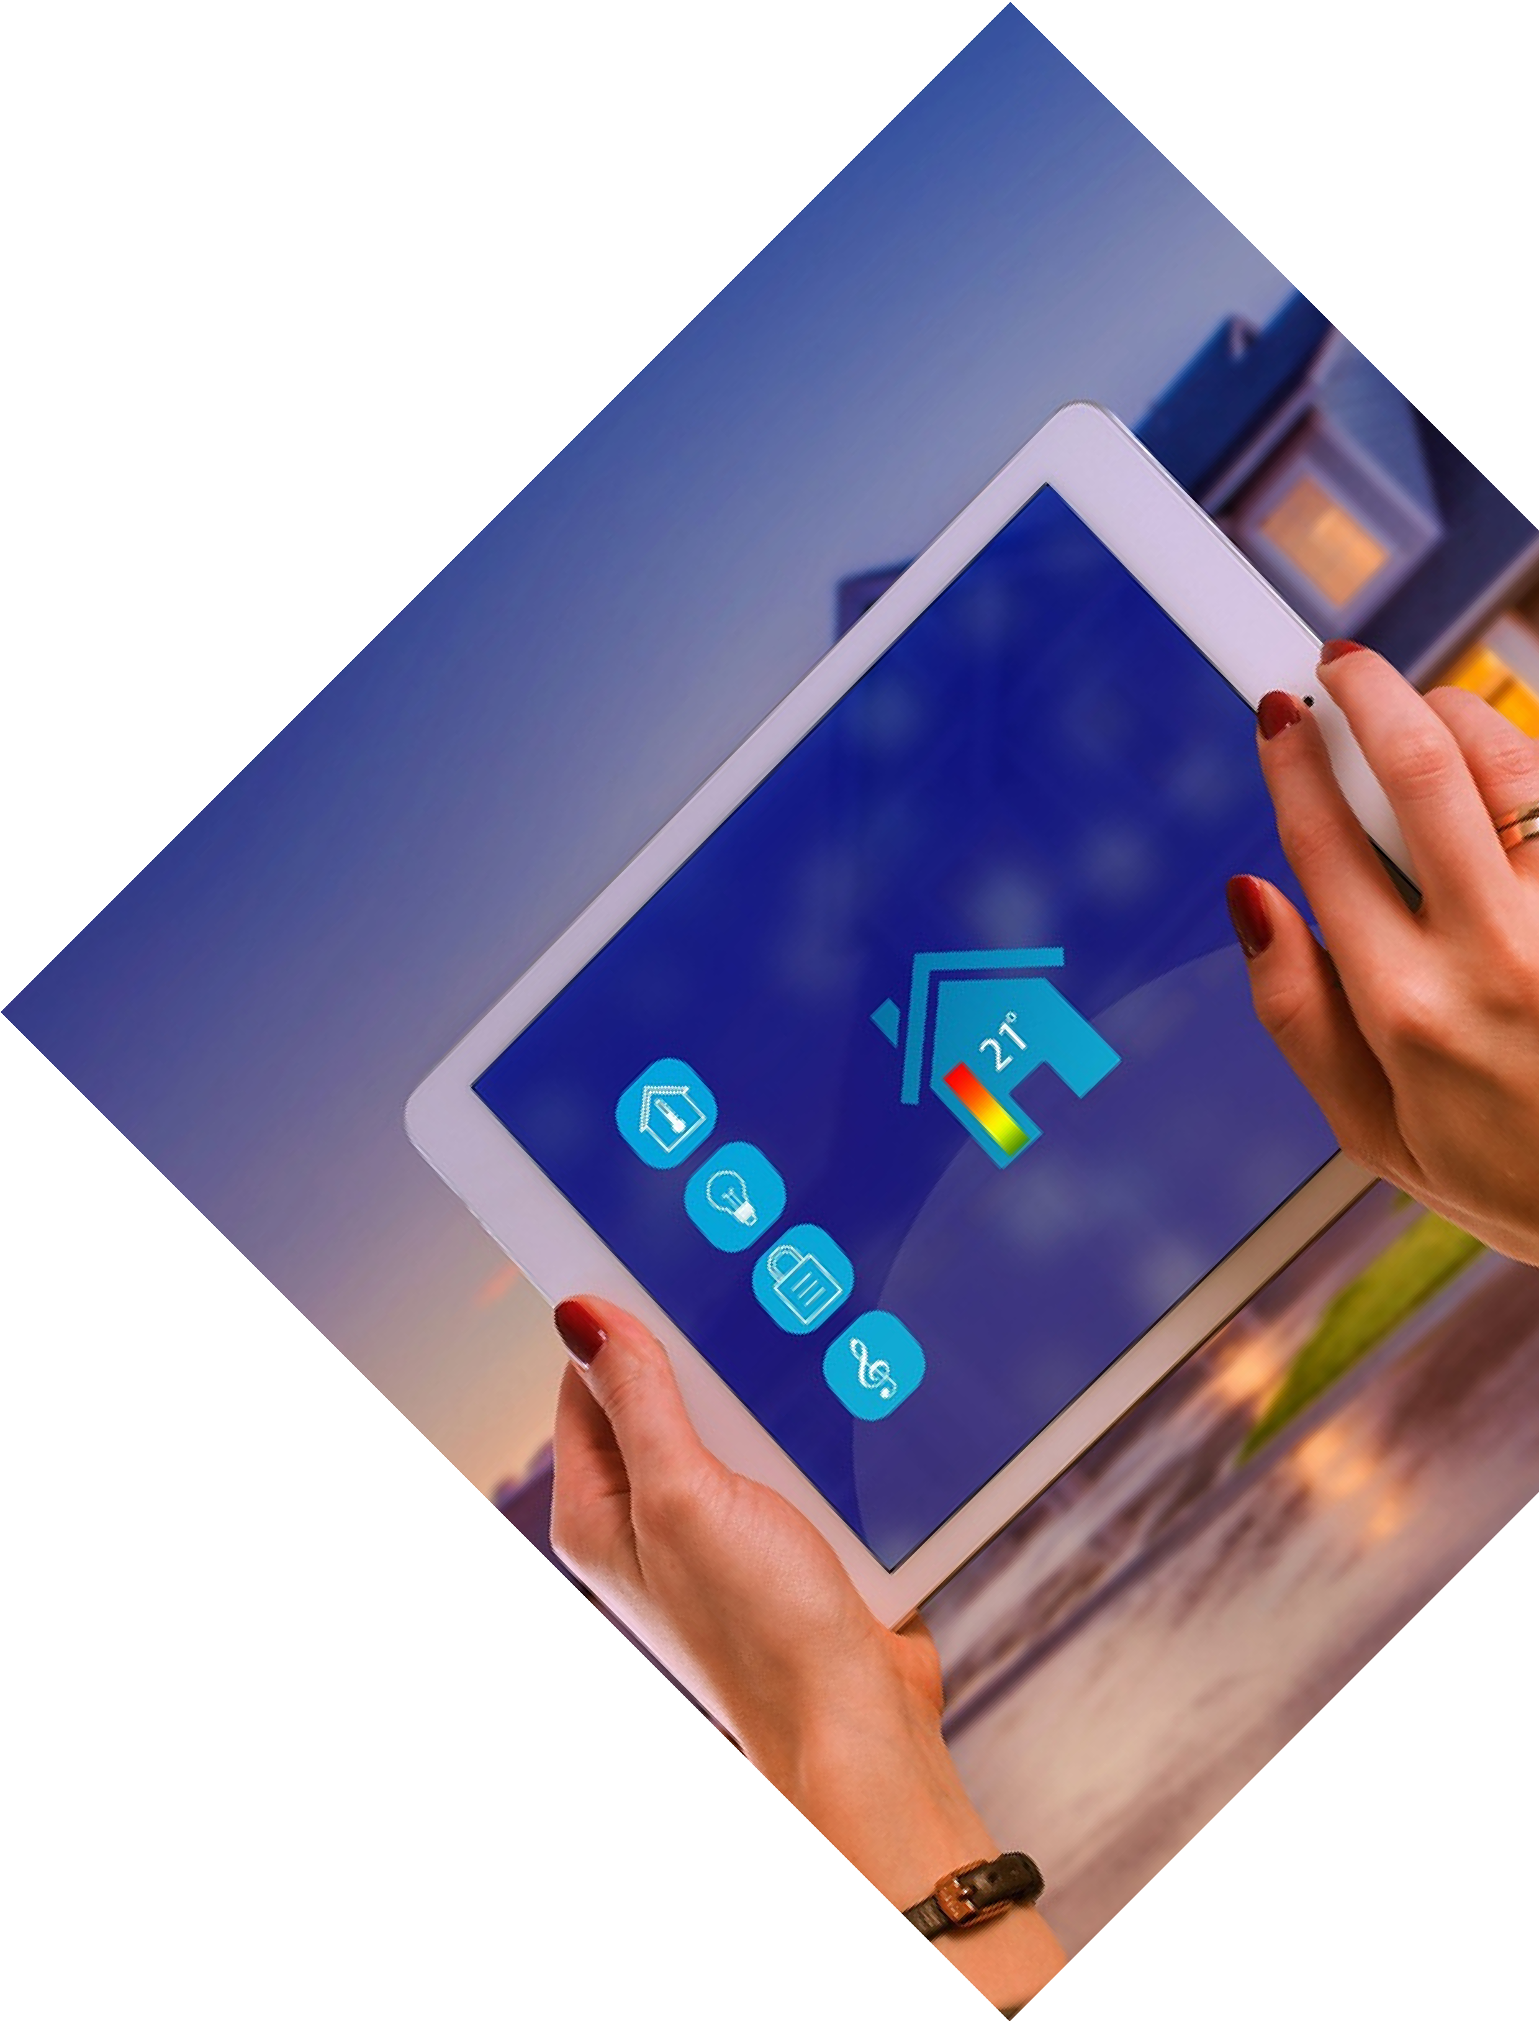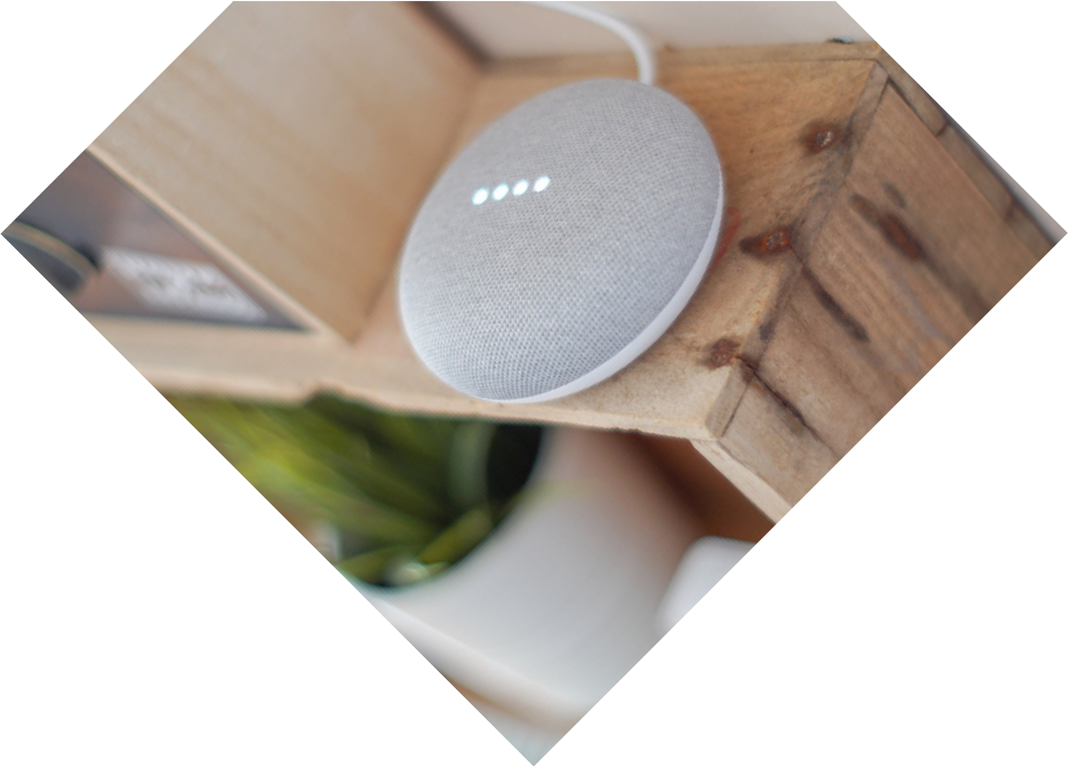Call For Booking :

www.visiltech.com

HOME LIGHTING
CONTROL
Illuminate your space with
precision and elegance.

Our advanced lighting control systems allow you to create the perfect ambiance for any occasion.

From cozy movie nights to lively gatherings, you have complete control.

Set schedules, adjust brightness, and save energy effortlessly.
Outdoor Lighting Indoor Lighting
Customizable RGB Mood
lighting

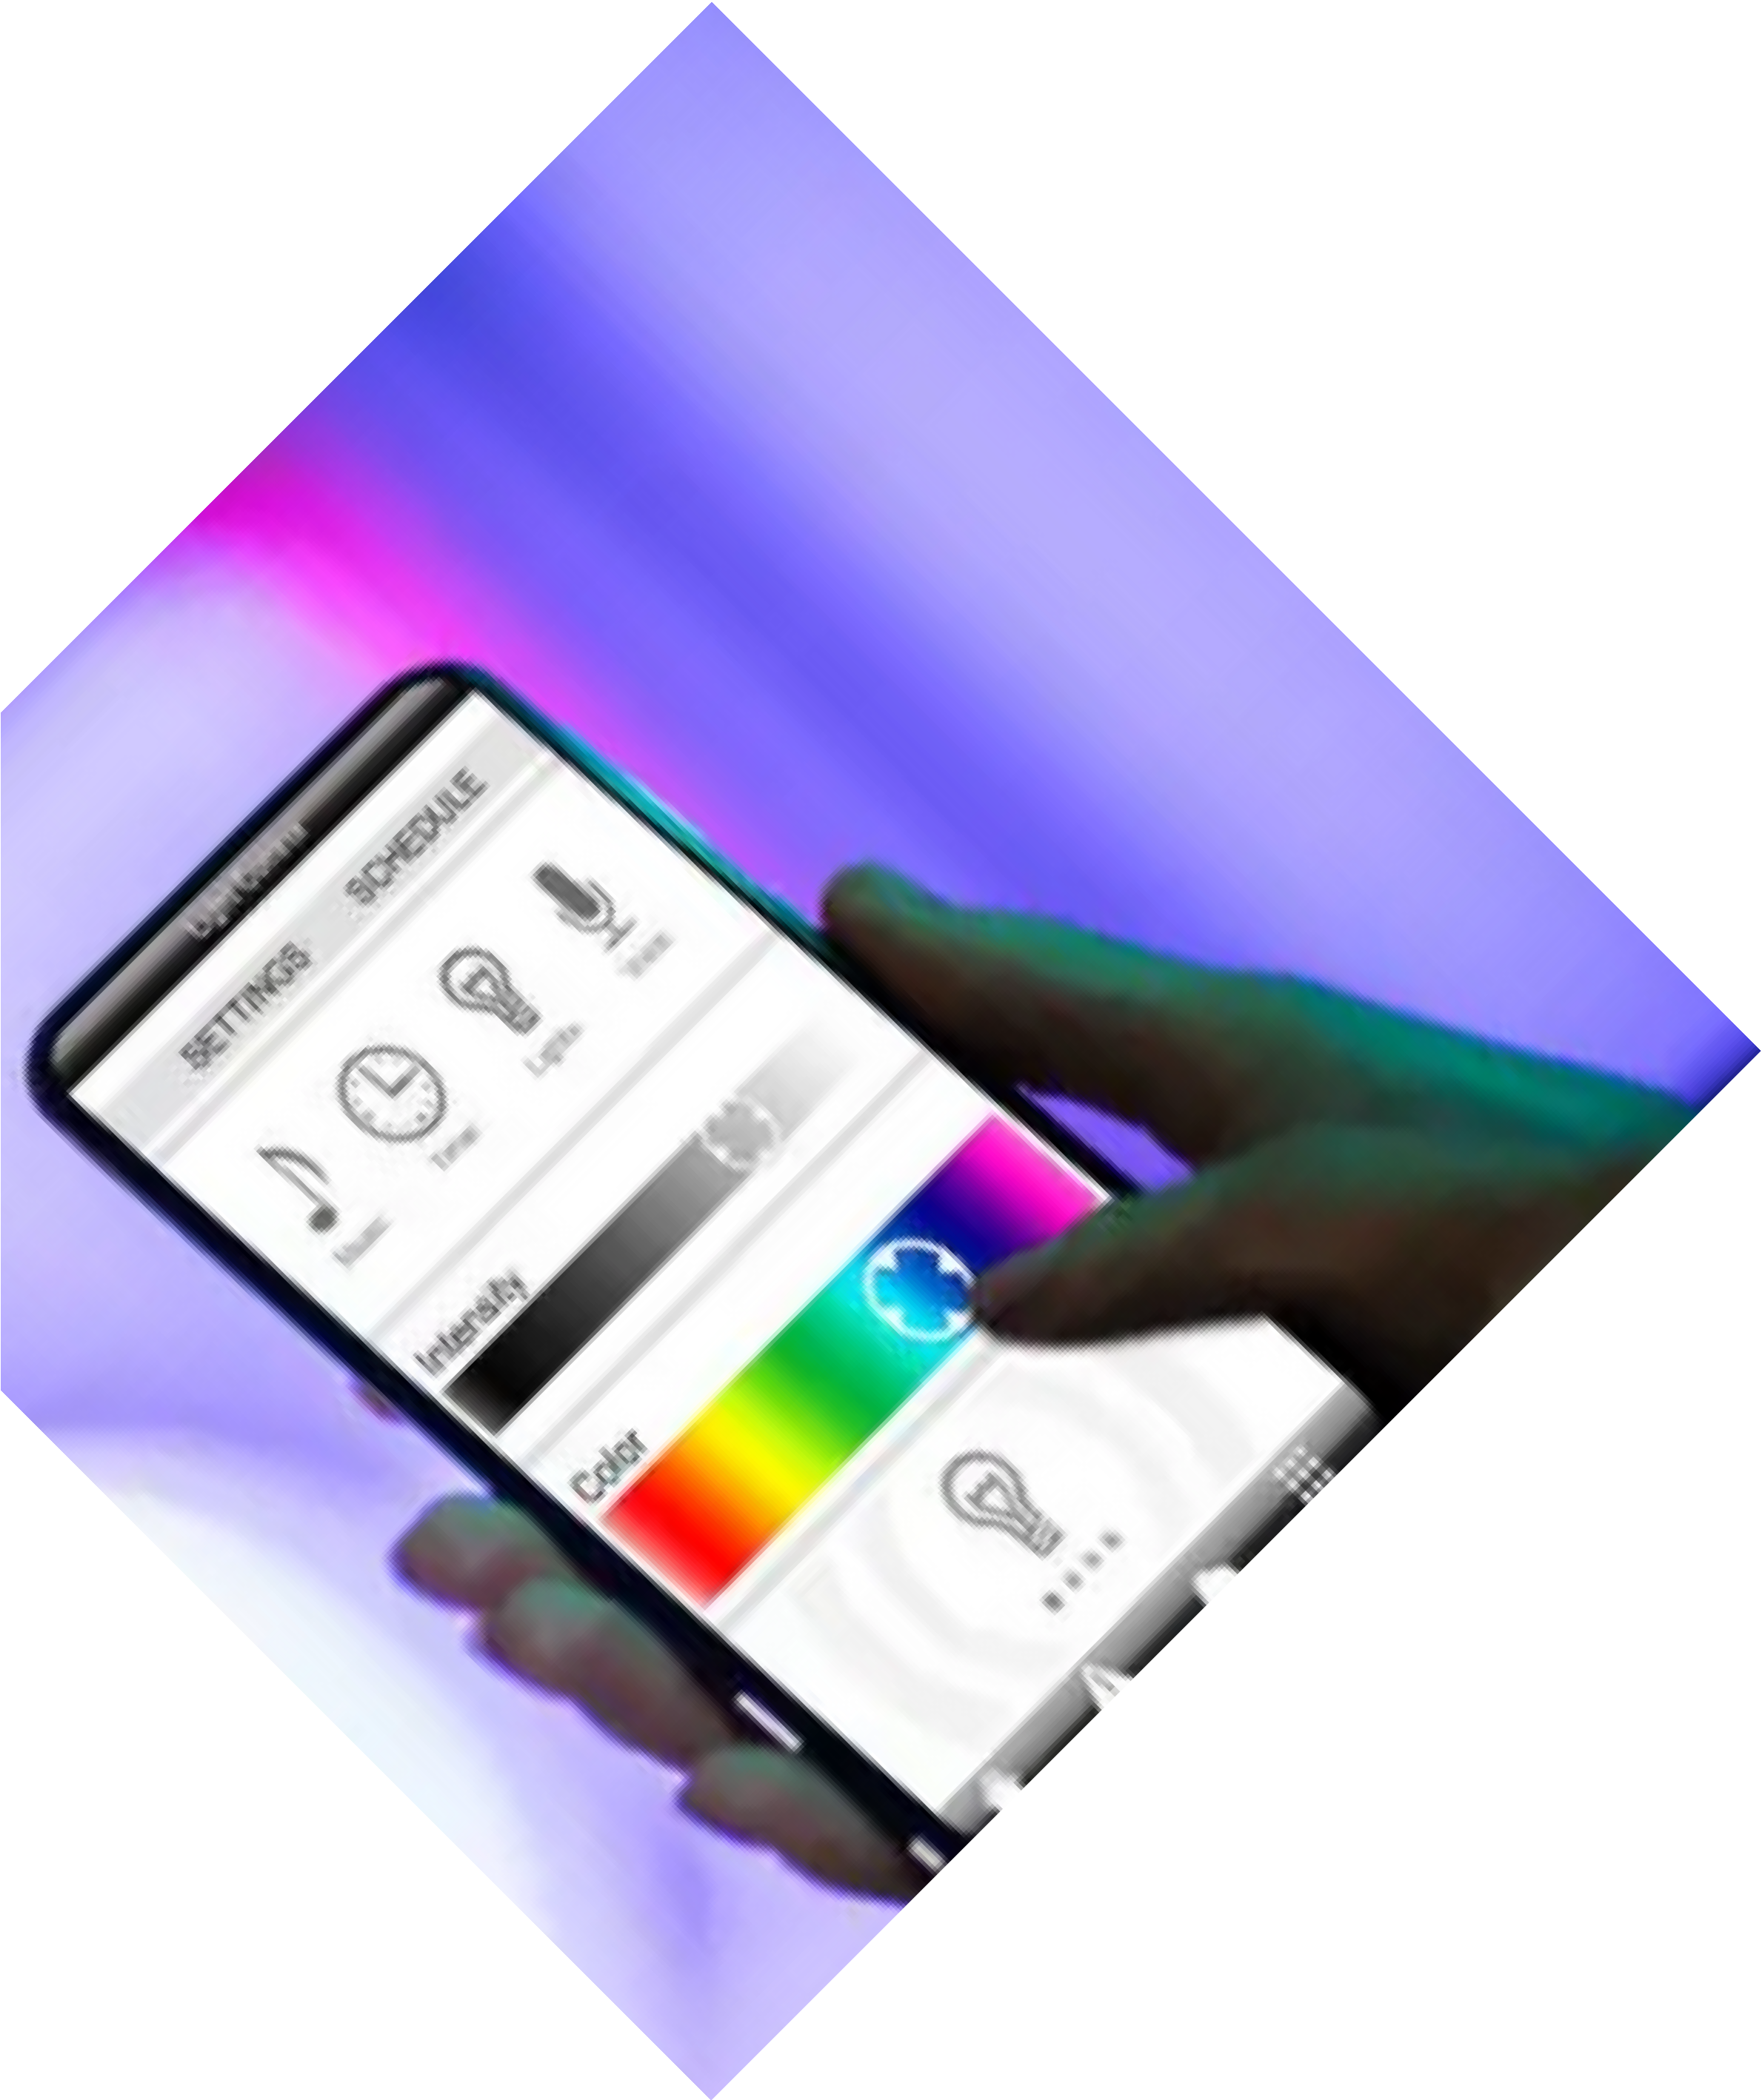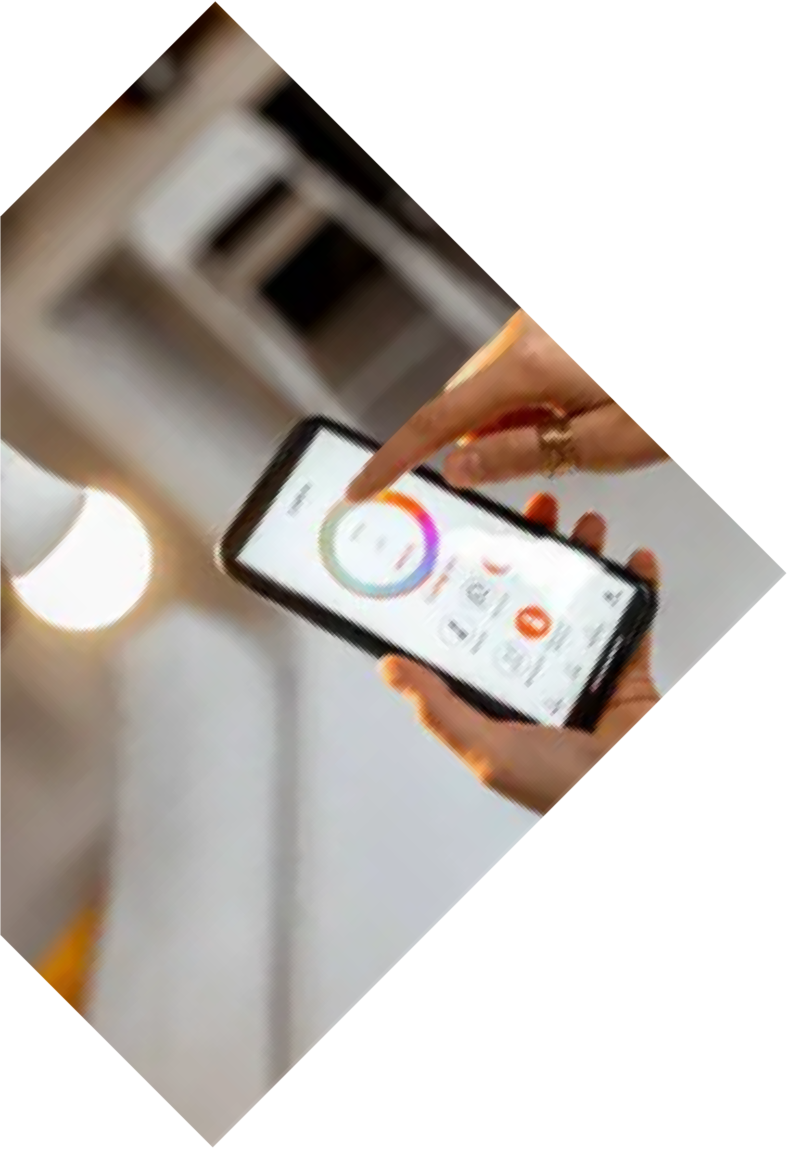Call For Booking :

www.visiltech.com

AUTOMATIC SWITCHES AND CONTROLS

Revolutionize the way you interact with your home.

Our smart switches put you in command, enabling you to control lights, fans, and more with a simple touch or voice command.

Experience unparalleled convenience and energy efficiency with intuitive switch control.

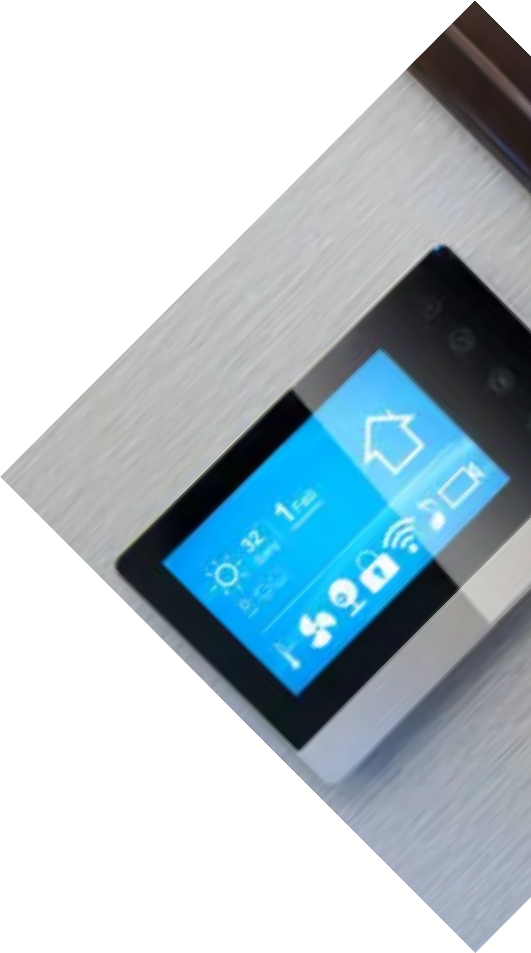Automated Kitchen Appliances Automated Water leakage switches Automatic Blinds and Curtains Automatic HVAC Systems.
Call For Booking :

89397-09676

www.visiltech.com

SECURITY SYSTEMS

Ensure the safety of your loved ones and property with our state-of-the- art security systems.

Monitor your home from anywhere, receive instant alerts, and take proactive measures to safeguard against intruders.

Our integrated security solutions
provide peace of mind 24/7.

Biometric Systems. Facial Recognition.
Real-time Home Monitoring. Smart Doorbell and Entry System.

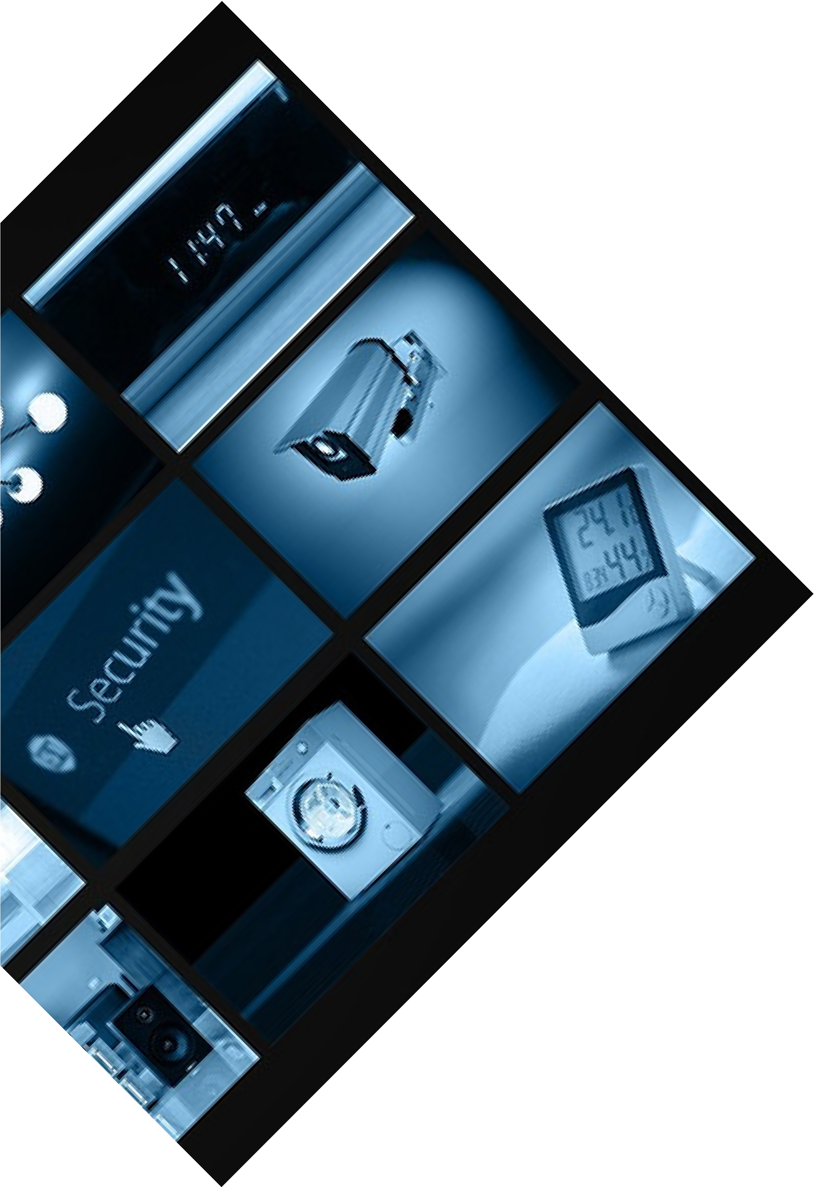Call For Booking :

89397-09676
www.visiltech.com

PET AND PLANTS CARE
Extend your care to your four-legged friends and flourishing plants, even when you're away.

Our smart systems enable you to remotely monitor and manage pet feeding, watering, and environmental conditions.

Ensure your pets and plants thrive with our thoughtful automation solutions.

Timely Feeding of Pets Timely Watering of Plants Sanitizing Pets
Real-time Monitoring of Pets

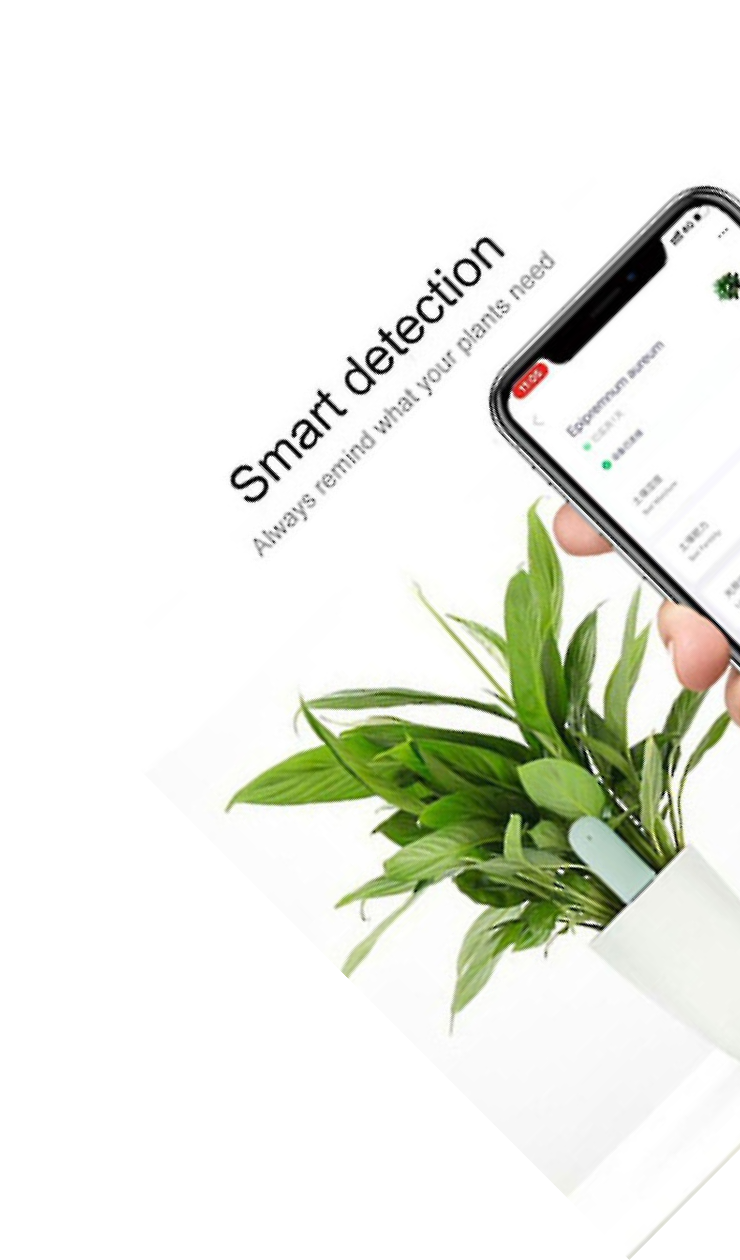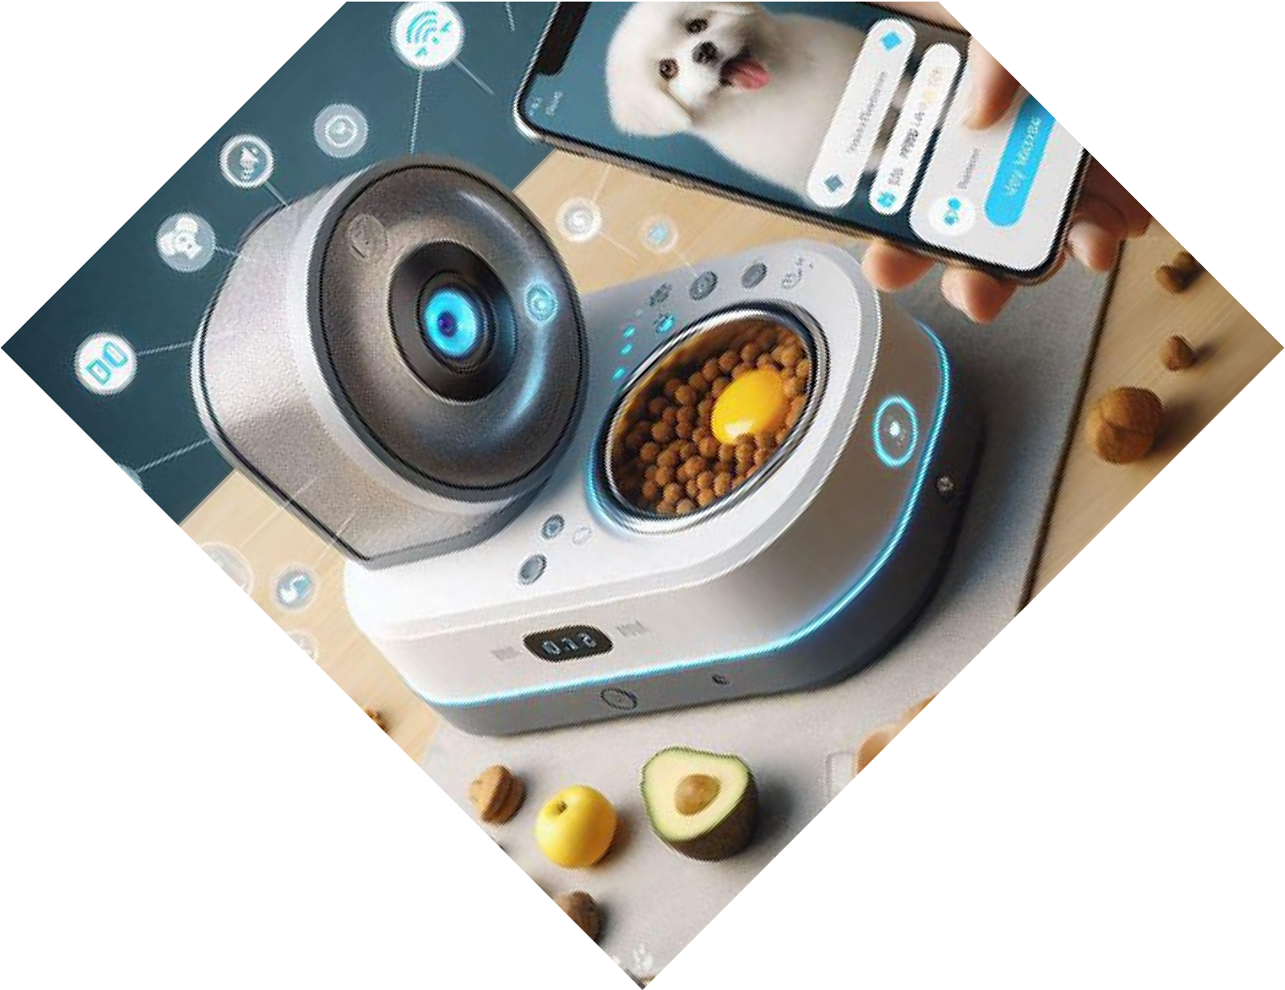Call For Booking :

89397-09676

www.visiltech.com

INTEGRATED BUILDING
CONTROL
Our Building Management System (BMS) delivers a powerful, all-in-one platform designed to streamline the control and automation of essential building functions.

Whether it’s HVAC, lighting, security, energy management, or other critical operations, our system ensures seamless integration and real-time monitoring.
Comprehensive Automation Energy Efficiency
Enhanced Security User-Friendly Interface Scalability
Smart Alerts

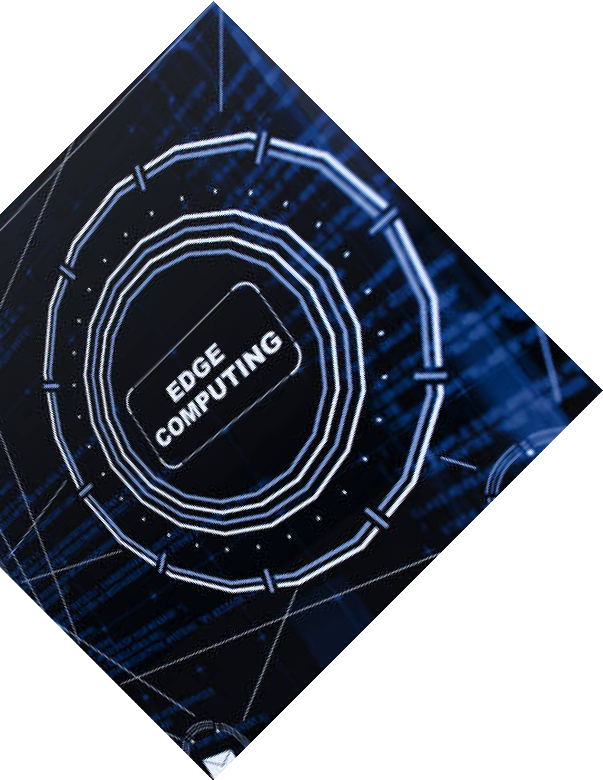Call For Booking :

89397-09676

www.visiltech.com

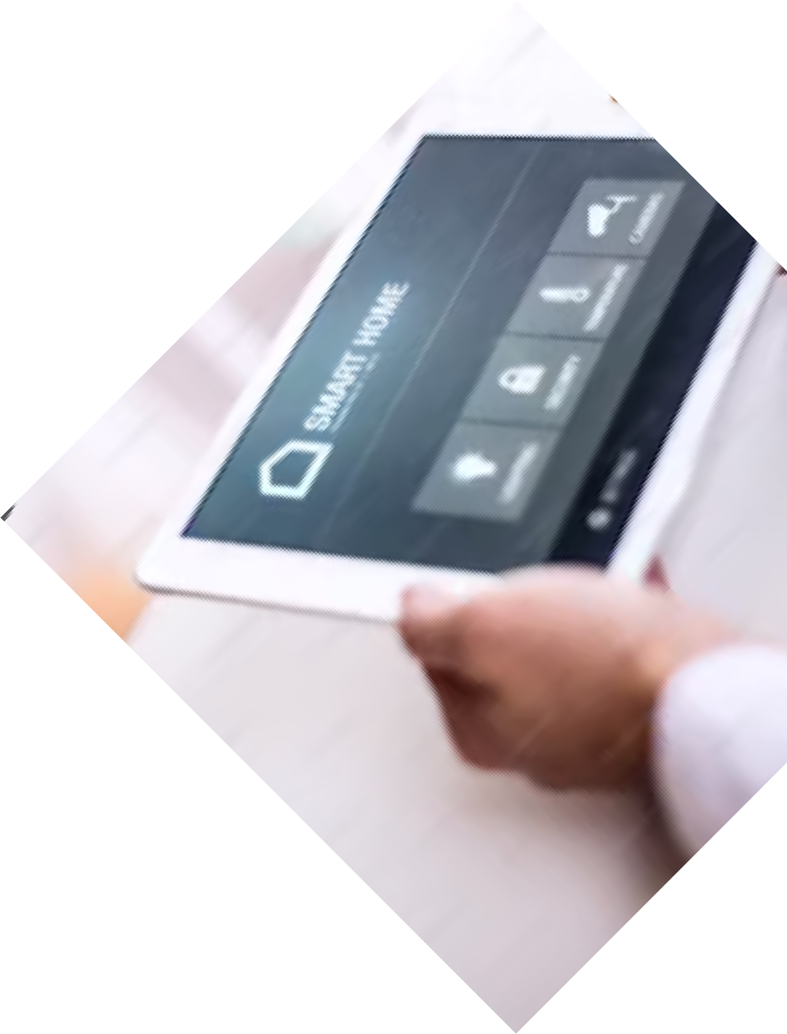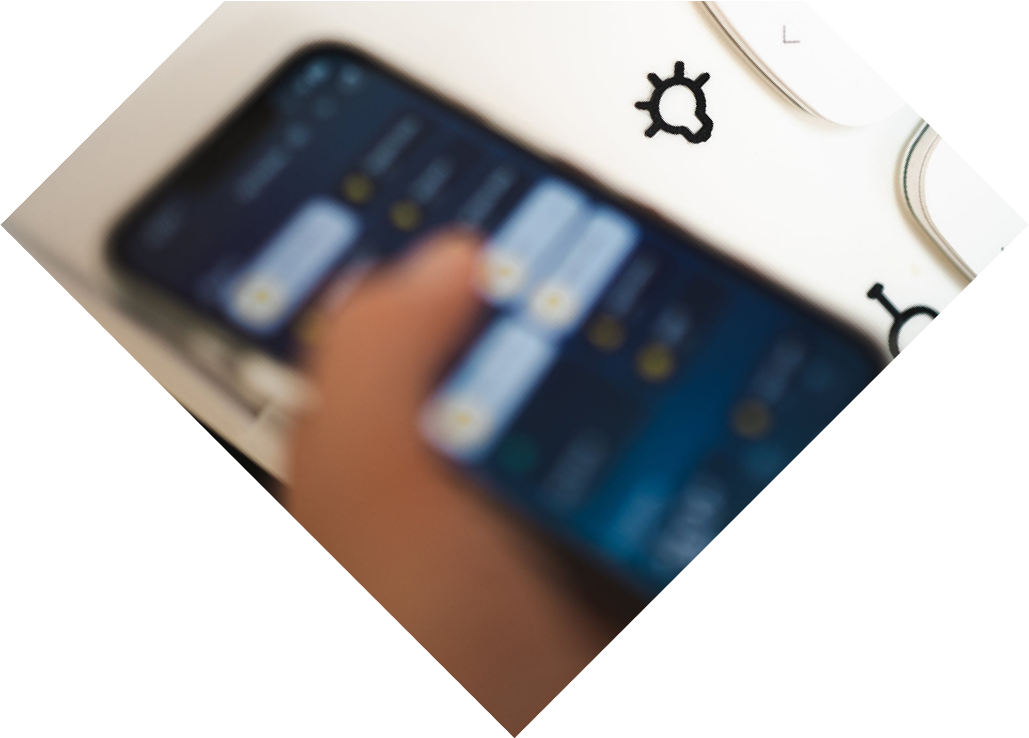

CONTACT US
250/15, Periyar Pathai, Choolaimedu, Chennai, Tamil Nadu 600094
+91 89397 09676

connect@.visiltech.com

SCAN TO KNOW MORE

www.visiltech.com

